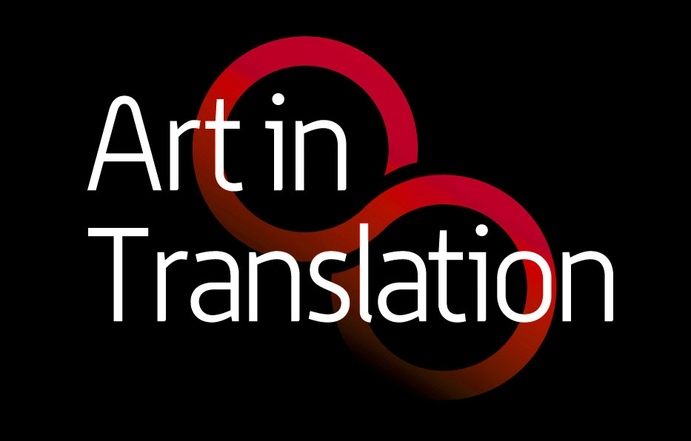

**Recommendation of a text for translation and publication in the Anthology: *European Art Writing on the Art of the United States 1945-1990***

This anthology focuses on the reception of the art of the United States of America in the non-English language writings by art historians, philosophers, art critics and artists in Continental Europe between ca. 1945-1990. It will make key primary sources on US art available for the first time in English translation. The anthology is a special project of the editors of the journal *Art in Translation* (Iain Boyd Whyte and Claudia Hopkins, University of Edinburgh) in collaboration with an expert panel on US art. For information, see www.usartineurope.eca.ed.ac.uk/

To recommend a text for translation and publication in this anthology, please complete and return this form to [**artintranslation@ed.ac.uk**](mailto:artintranslation@ed.ac.uk).

If the proposed text is selected, the editors will acknowledge in print that the text was suggested by you. You might also be invited to write a short introduction for publication with the translated text.

**Your details**

Name:

Affiliation (if applicable):

Email:

**Recommended text:**

Author:

Title:

Published in which journal or book:

Year of publication / volume number:

Page numbers:

Number of illustrations:

ISBN number (if known) :

Language:

|  |  |
| --- | --- |
| To what extent do the following qualities apply to the recommended text? Use a scale from 1 to 10 (10 being the best score) to assess the text. |  |
| * The text makes a significant contribution to the understanding of the reception of US art in Europe |  |
| * The text is groundbreaking within the field of art writing on US art, opening new paths of enquiry |  |
| * The text is representative of the source culture, and methodology involved. |  |
| * The text represents a classic text on postwar US art within the source language. |  |

**Who is the author? What makes this article special, original and important? Please comment briefly (25-50 words max):**

**Synopsis (200-600 words)**.

Please consider:

* a description of the scope, aims, arguments and contents of the text
* an indication of its significance in its original context
* the original target audience

**Scanned Copy**

Although not essential, it would be an enormous help if you could also attach a scanned copy of your recommended text.